***Tema Lab3***

1.a. IPv4 adress: 10.10.10.112

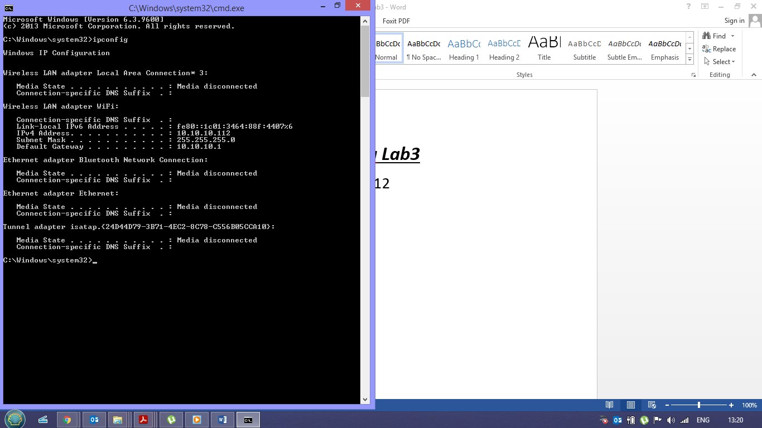

b.mac address:B4-6D-83-93-D6-22

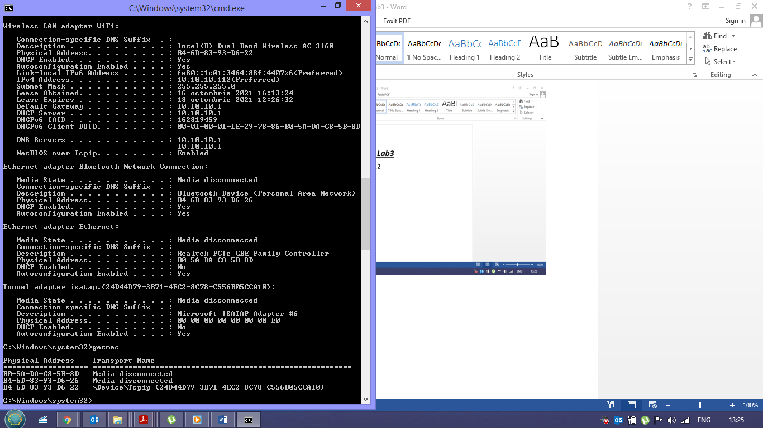

c.Tipuri de interfete de retea :

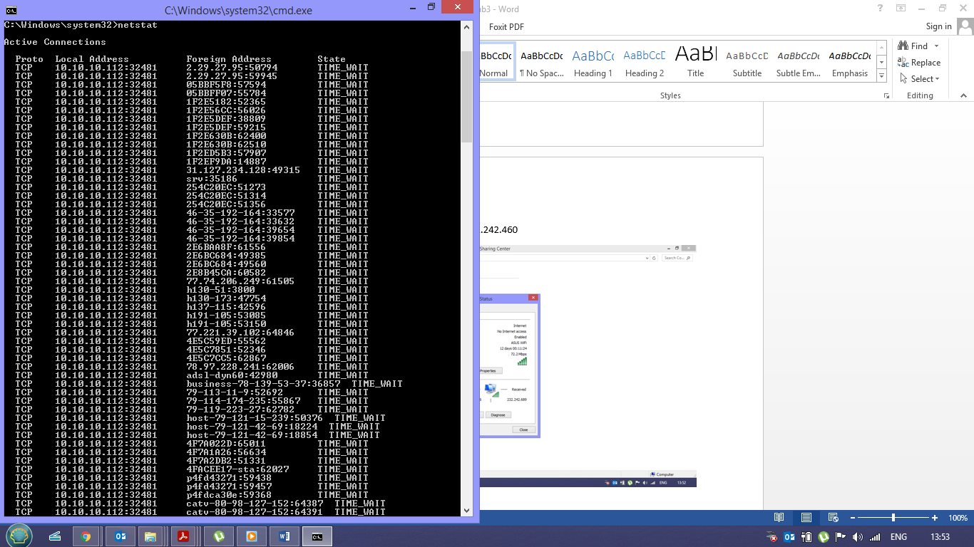

d.nr de pachete transmise:2.400.759.992 - 232.242.460

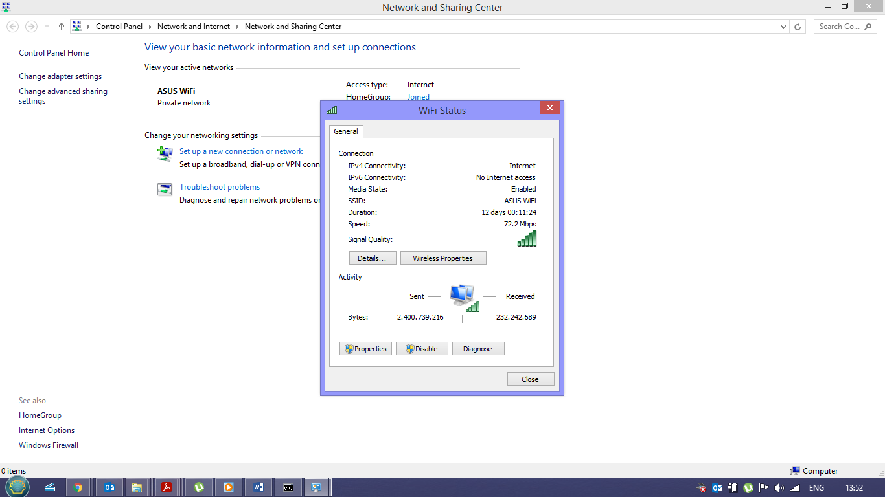

e.exemplificari de rute conectivitate:LAN,PAN,MAN,WAN

2.a.3 procese in ordinea consumului de resurse:

1.chrome.exe:PID:13080, Threads:15,CPU:0,Average CPU:0.01

2.cmd.exe:PID:12536, Threads:1, CPU:0, Average CPU:0.00

3.audiodg.exe:PID:12200, Threads:12, CPU:0, Average CPU:0.51

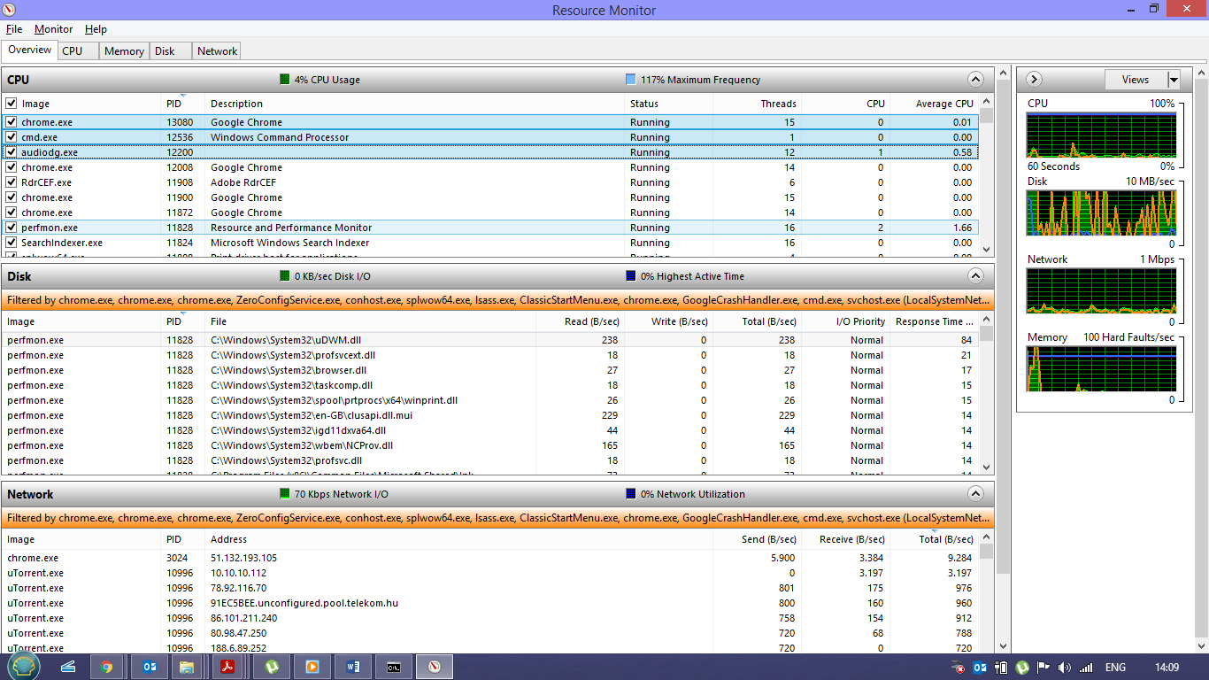

c.

1.uTorrent: CPU:0%; Mempry:37.9MB; Disk:0MB/s; Network:0.1Mbps

2.Adobe Acrobat: CPU:0%; Mempry:113.3 MB; Disk:0MB/s; Network:0.1Mbps

3.Google chrome: CPU:0%; Mempry:171.8MB; Disk:0MB/s; Network:0.1Mbps

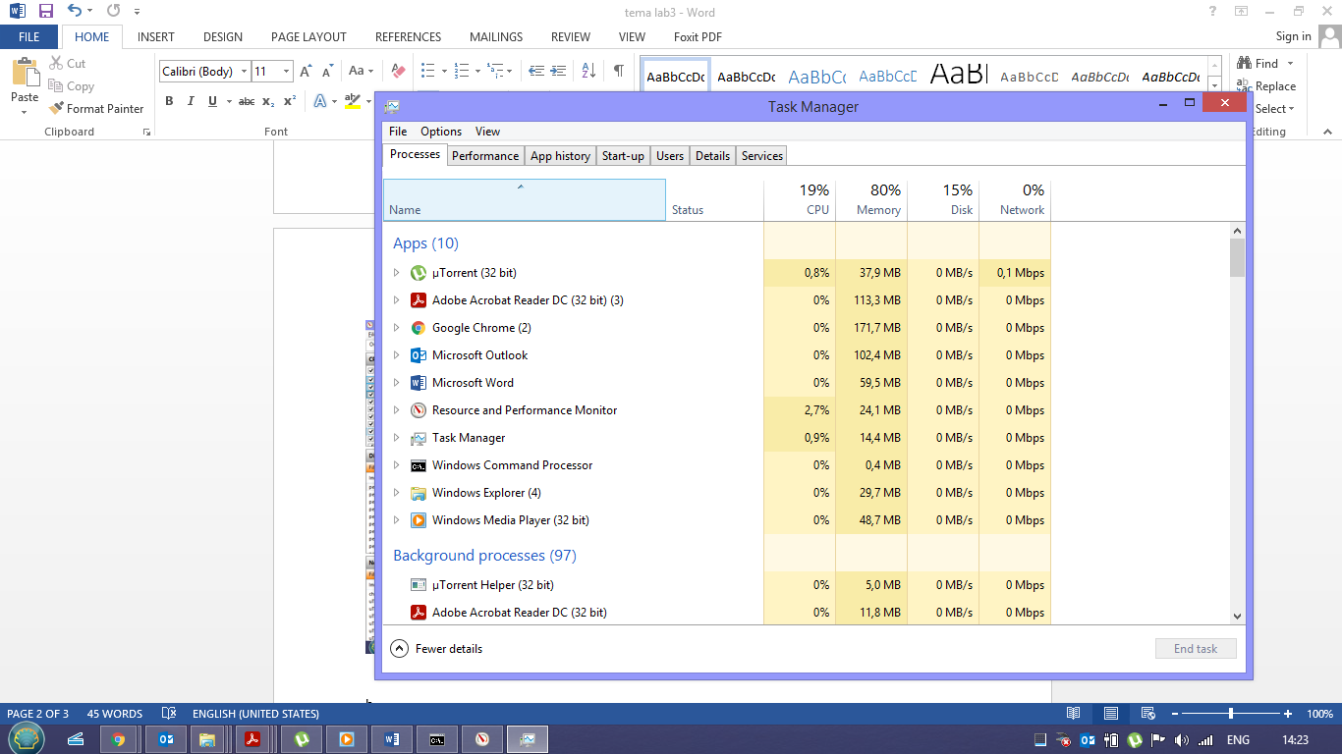

b.

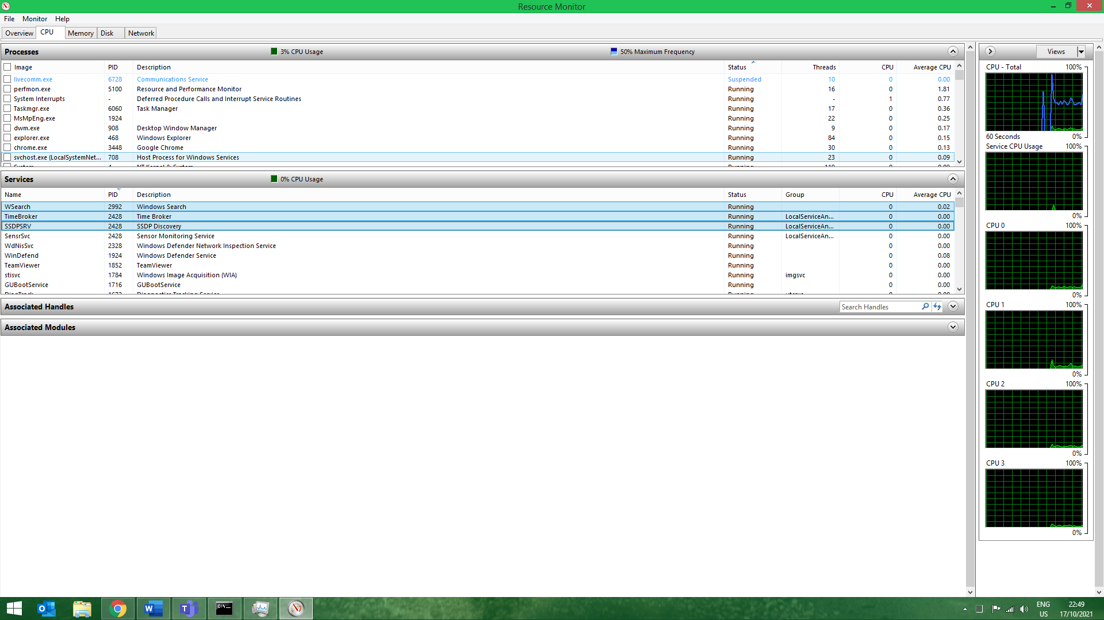

d. 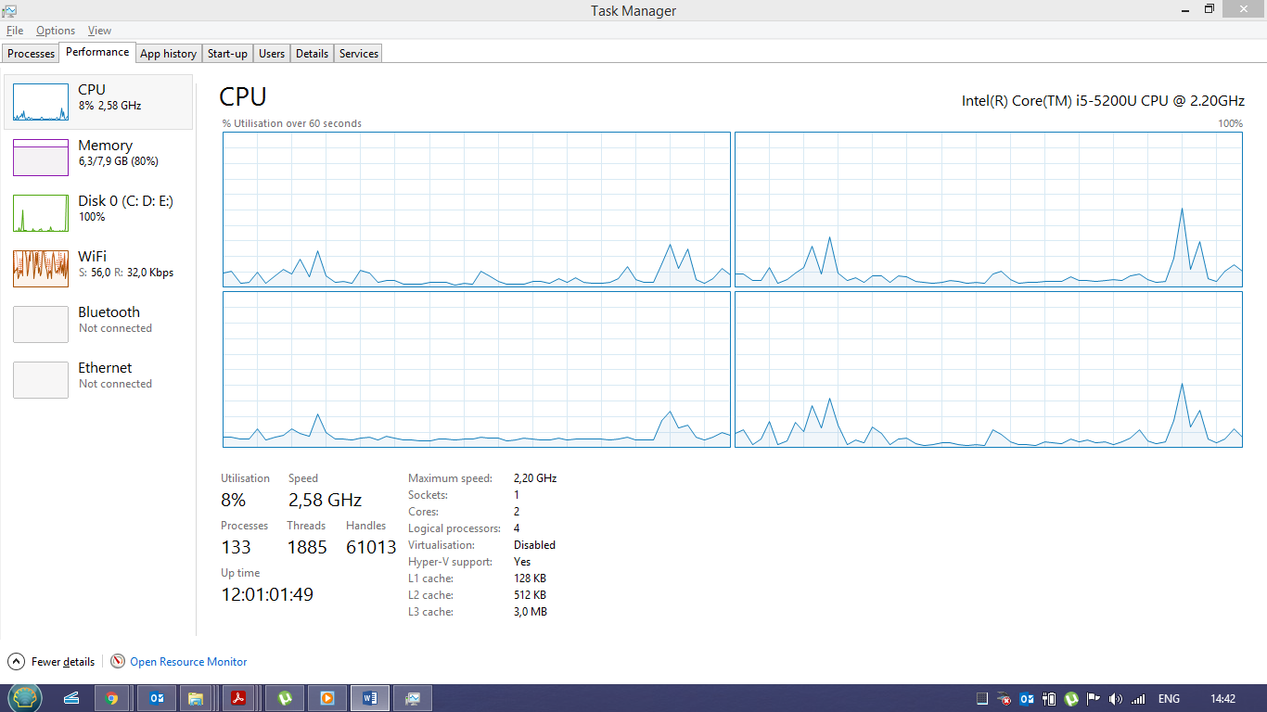

e. 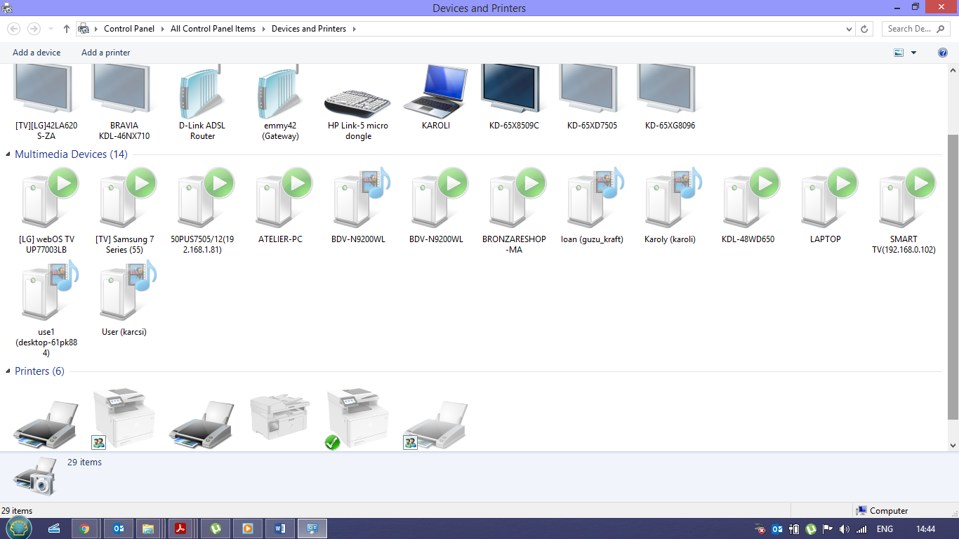

3.

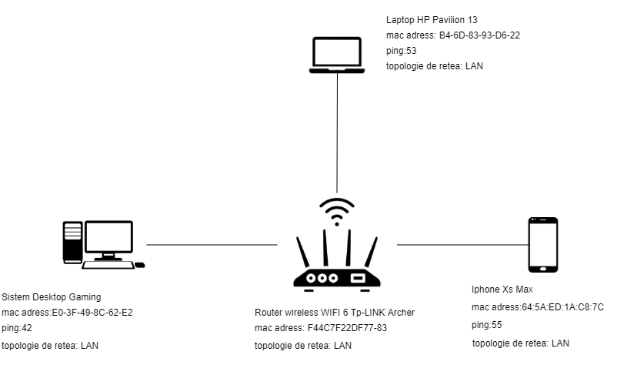

4.1

R:1600X1200 PX

8BITI

1. Rata:1MBps

C=1600x1200x8=15,36Mb

R=C/t => t=C/R=15,36/1=15,35 =>t=15,36s

1. Rata=10Mbps

C=15,36Mb

t=C/R=15,36/10=1,536s

1. Rata=1000Mbps

T=C/R=15,36/100=0,1536 s

1. Rata=1Gbit

t=C/R=15,36/1000=0,01536

4.2

Fiind 10 linii diferite+4 linii de viteza =>10^4 tipologii=1.04.576 tipologii

100ms*1.04.576=0,1*1.04.576=104,857,6s